**Analyze Boston Crime**

**ALY6070: Initial Analysis**

Rebecca Leu

2020

**Variables in the data**

* The location of the crimes given in:
  + Latitude and longitude
  + Reporting area
  + Street
  + District
* Time of the crimes given in:
  + Hour of the day
  + Date (month/day/year)
  + Day of the Week
* Type of crime subdivided by:
  + Incident number
  + Offense code
  + Offense code group
  + Offense description

**Correlations, patterns, or trends**

While looking at the crime counts per variable listed above, it is clear there are some trends and patters in the data. First off, some offenses have higher rates then others. Below are the highest counts of the different type of crimes over the entire history of the data.

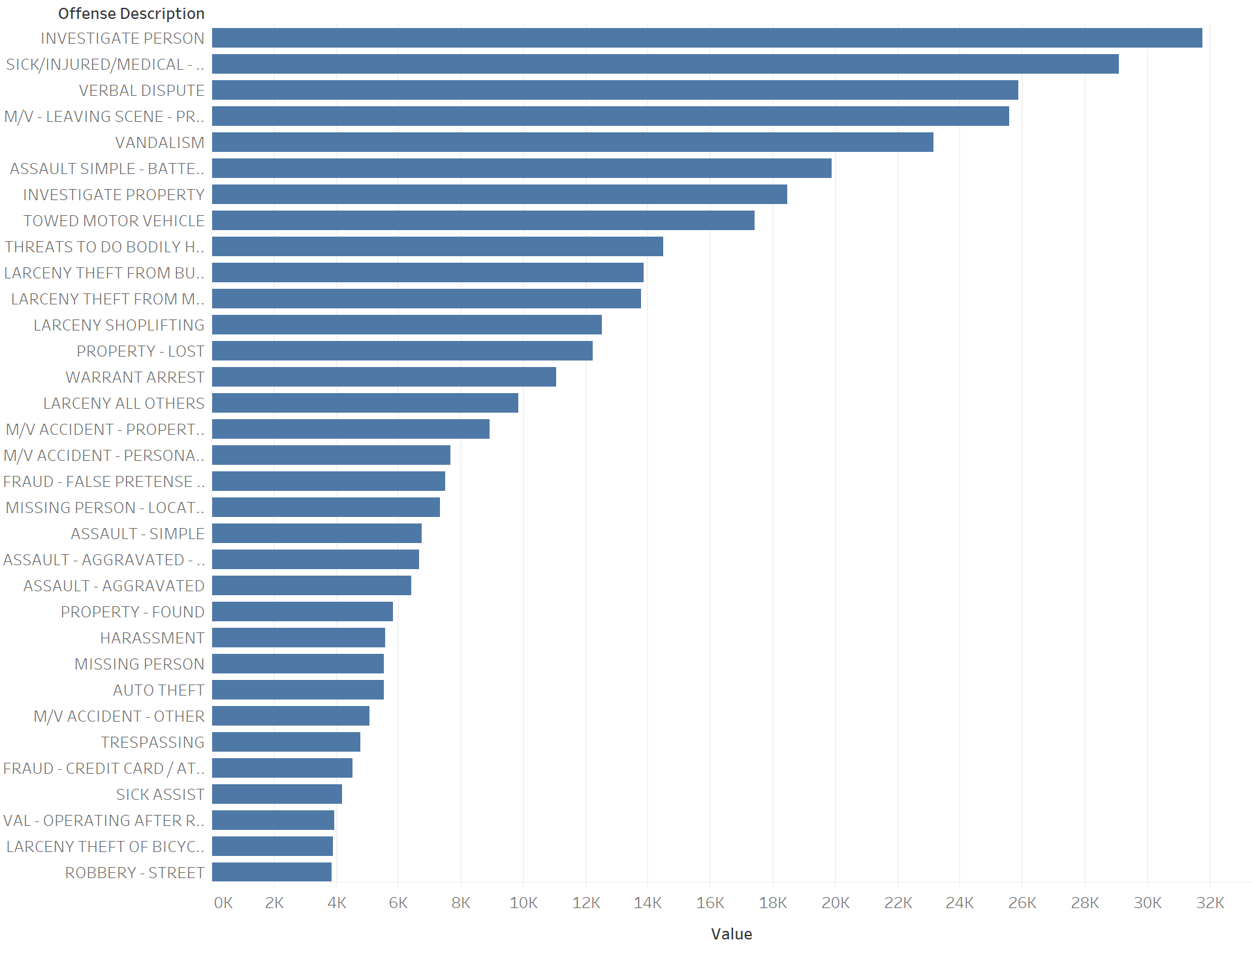

A graph of the crime reports per district show that crime rates vary greatly by district with B2 having about 8 times more crime reports than the lowest district A15.

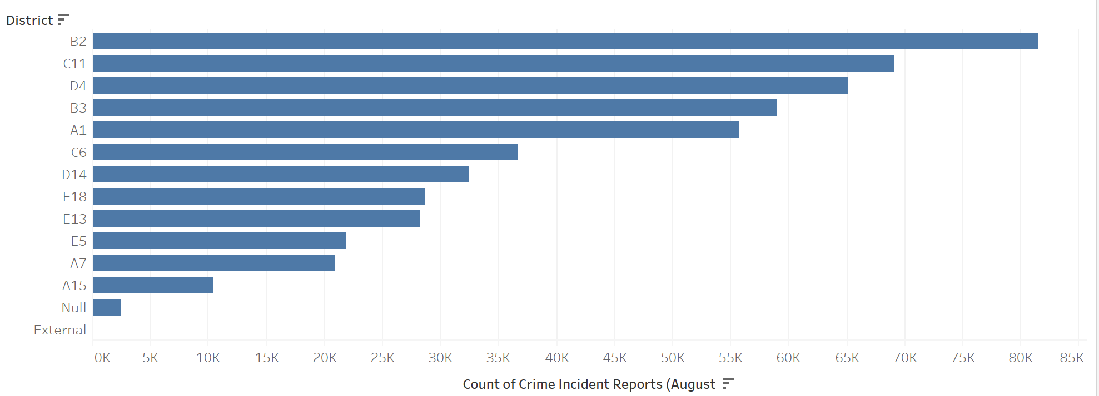Looking at the time the crimes are reported, crime counts climb sharply during spring with the highest crime rates happening in August. After August things start to go down again as the days get shorter and colder.

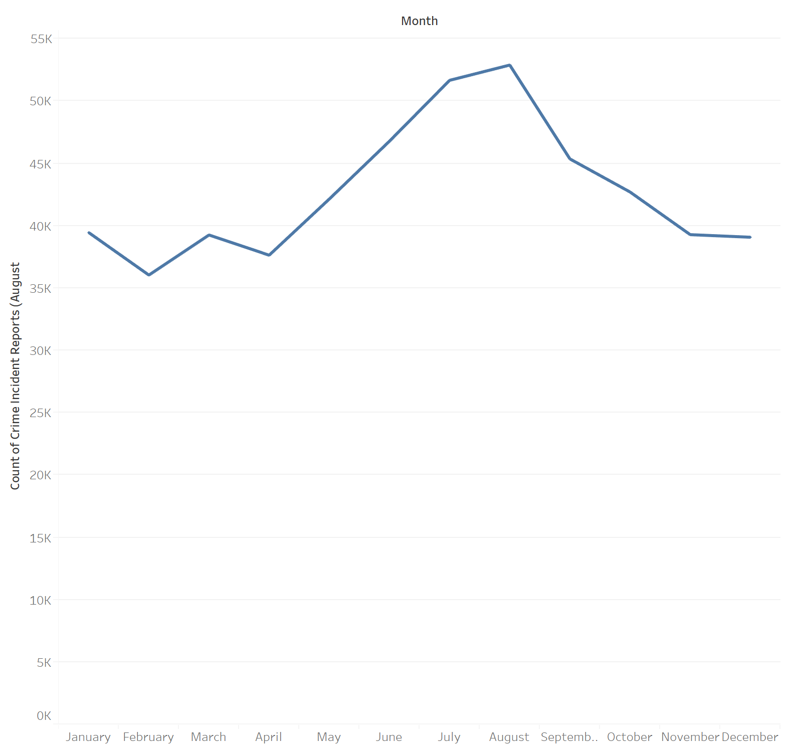

When we look at the crime count for each day of the week, it appears crime is at its greatest on Fridays and its lowest on Sundays.

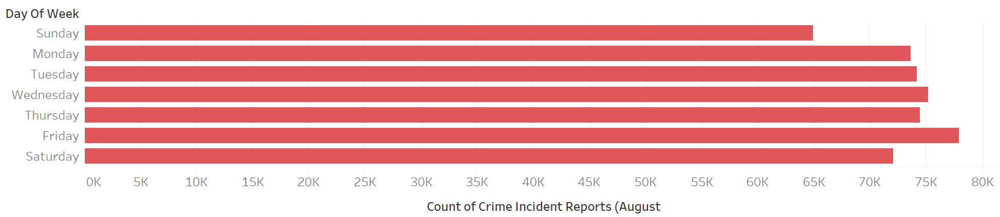

**Audience**

The audience to this data could be anyone who works in law enforcement. But this data could be most helpful to management to plan for staffing times during the year as well as where to staff more law enforcement. The data could also be separated by crime type so that programs or teams could be created to try and crack down on a certain type of crime in an area. For instance, we could find that car theft is prominent in the south side of the city more than any other area of the city. We could also track down when these crimes usually take place and up staffing during that time, in that area to try and catch the criminal in the act. As an individual contributor, this data could be viewed by each law enforcement officer to determine what kind of crime they should be on the lookout for and when.

**Questions the data could answer**

What areas of the city have the highest concentration of crime? Are there pockets of certain types of crime in one area?

What time of the year is busiest? What day of the week and what time of day has the most crimes?

What kinds of crime have the highest incident counts?

**How a dashboard could be beneficial**

A dashboard of data could be used for law enforcement agency management. The management could look at the data for their area and determine staffing needs, trends in types of crime or when crime is happening. It could also be beneficial for individual law enforcement officers to see what kind of crimes to be on the lookout for, or to be aware of greater amounts of crime during the year.

**Types of graphs and charts that could be used**

Crime reports per district

Types of crime reports per district

Crime by the day of the week

Crime incidents per month

Offense description and the count of each